Welcome to the Pediatric Care Medical Conference Access Guide

Dear Attendees,

Welcome to the Pediatric Care Medical Conference Access Guide! We are thrilled to have you join us for this impactful event focused on universal pediatric care. This comprehensive guide has been curated to ensure that your experience at the conference is both informative and accessible.

Throughout the conference, you will have the opportunity to engage in various sessions, including general sessions covering influential clinical research in pediatric care, panel discussions, and a dynamic tabling event showcasing pharmaceutical companies, medical technology advancements, and more.

We are committed to providing a supportive environment where all attendees can fully participate and benefit from the wealth of knowledge and expertise shared during the conference. Should you have any additional needs or require specific accommodations, please do not hesitate to contact us at [conferenceemail@universityofalabama.edu](mailto:conferenceemail@universityofalabama.edu) or call us at (205) 555-1234. Our team is dedicated to meeting every attendee's needs to facilitate a seamless and enriching experience.

We are delighted to extend exclusive invitations to this event, ensuring a focused and intimate gathering of esteemed guests. As an invite-only occasion, attendees have been carefully selected based on their expertise, contributions, and significance to the field. This curated approach allows for meaningful interactions, insightful discussions, and valuable networking opportunities. We look forward to welcoming our distinguished guests and fostering a memorable experience for all who attend.

We look forward to welcoming you to Hewson Hall at the University of Alabama and engaging in meaningful discussions and collaborations surrounding pediatric care.

Best regards,

Pediatric Care Conference Organizing Committee

# Contacts

**Conference Director**:

John Kravinsky

(205) 555-4321

[jkhealth@pediatrics.com](mailto:jkhealth@pediatrics.com)

**Conference Secretary**:

Donna Davenport

(205) 555-9876

[ddhealth@pediatrics.com](mailto:ddhealth@pediatrics.com)

**Event Coordinator:**

Erika Johnson

(205) 555-6543

[ejhealth@pediatrics.com](mailto:ejhealth@pediatrics.com)

**ADA Coordinator:**

Kenneth Jerald

(205) 555-5432

[kjhealth@pediatrics.com](mailto:kjhealth@pediatrics.com)

# Birmingham-Shuttlesworth International Airport (BHM)

Birmingham-Shuttlesworth International Airport is a full-service international airport that offers scheduled, nonstop passenger and cargo service. BHM is the largest airport in Alabama, ranking in the top 75 airports in the country in terms of passengers served annually.

Pickup and Dropoff is located on the lower-level of the airport.

## General Information

Website: [www.flybirmingham.com](http://www.flybirmingham.com)

Address: 5900 Messer Airport Hwy, Birmingham, AL 35212

General Phone (includes lost and found): (205) 595-0533

Parking Information: (205) 599-0730

- Valet Parking: (205) 767-5775

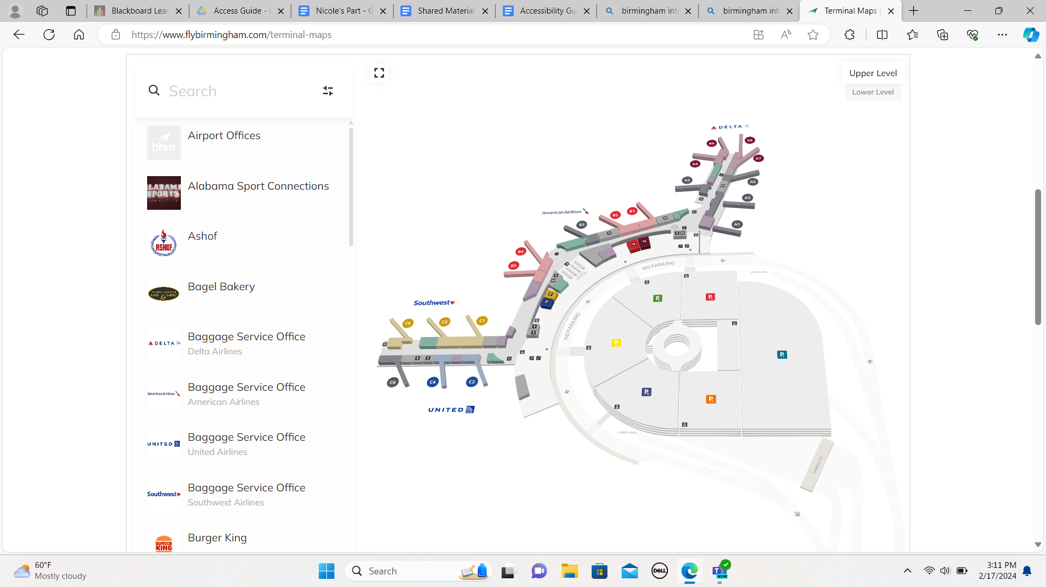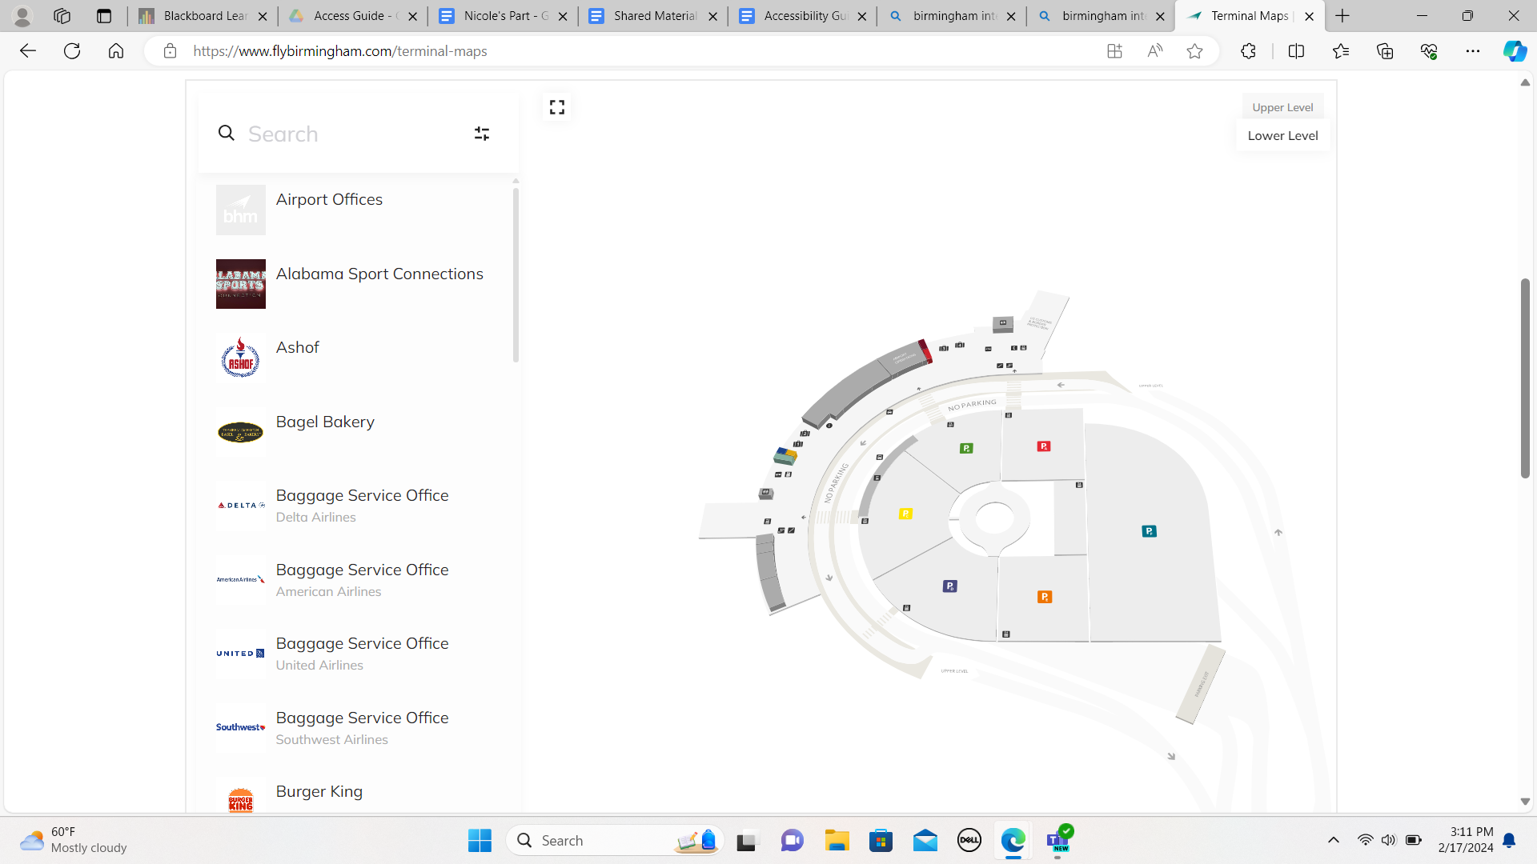

Image Descriptor: (First Image) Aerial-view of the first floor of Birmingham-Shuttlesworth Airport. The floor plan is broken up into three different terminals: A, B, and C.

(Second Image) Aerial-view of the ground floor of Birmingham-Shuttlesworth Airport. This has the pick-up, drop-off, rental car services, and parking.

## Pick-Up and Drop-Off Area

All rental cars may be picked-up or dropped-off in the parking deck located on the ground level. Please contact your rental car company in the event of a delayed flight for all inquiries concerning your reservation.

Once you have acquired your rental car you can use a map app such as google maps or apple maps to get directions to Hotel Capstone (see below).

# Transportation Options to Tuscaloosa

## Rideshare

You can use Uber or Lyft for direct transport to Hotel Capstone from Birmingham Airport.

### Uber

**Please follow the instructions below on how to book your Uber ride:**

1. First download the Uber app: Download the app | Uber
2. Setting Locations: In the pickup section, input Birmingham Airport. The address is 5900 Messer Airport Hwy, Birmingham, AL 35212. In the dropoff section input Hotel Capstone, located at 320 Paul W Bryant Dr, Tuscaloosa, AL 35401

**Pickup at Birmingham Airport (BHX)**

#### Open your app to request a ride

When you’re ready, open the Uber app to request a ride to your destination. Choose the BHX airport transportation option that suits your group size and luggage needs.

#### Follow directions in the app

You’ll receive directions to Birmingham Airport pickup points directly in the app. Pickup locations may vary by terminal. Rideshare pickup signs may also be available at Birmingham Airport.

#### Meet your driver

Go to your assigned BHX pickup location as specified by the app. Please note that this location may not always be at your nearest exit. Your driver’s name, license plate, and car color will be shown in the app. Verify your ride before you get in. If you can’t find your driver, contact them through the app.

### Lyft

**Please follow these steps below on how to book your Lyft ride:**

1. First download the Lyft app: Ride with Lyft
2. Create a new account or login to an existing one
3. Tap ‘Search destination’ and enter your drop-off location
4. Select your preferred ride type. You can learn more about different types of rides at Lyft ride types overview
5. Tap ‘Select Lyft’
6. Confirm or change your pickup location before tapping ‘Confirm and request’
7. Once you've enabled GPS locating in your phone settings, the Lyft app will automatically set your current address as the ‘pickup’ location
8. To add an extra stop during a ride, tap the ‘+’ icon next to the listed addresses at the top of the ride screen
9. If you’re making a stop or going to leave the car for more than 5 minutes, ask the driver to end the ride. Then, request a new ride when you’re ready to go to your next destination

**Airport rides**

You can select ride preferences to personalize your ride to or from the airport. This is available for all ride types.

The preferences you can select include

* Vehicle temperature
* Quiet ride
* Help with luggage

To select your preferences, tap ‘Personalize your ride’ while you wait for your driver to arrive.

Note: Some drivers may not be able to accommodate your selected preferences.

## Shuttle

You can use the website: Airport Shuttle Service - Groome Transportation - Book Online to book a shuttle from the Birmingham Airport to The University of Alabama Campus.

Addresses: Birmingham-Shuttlesworth International Airport: 5900 Messer Airport Hwy, Birmingham, AL 35212.

Hotel Capstone: 320 Paul W Bryant Dr, Tuscaloosa, AL 35401

**How to use the website:**

When you click the link below it will take you to the website’s homepage.

[Airport Shuttle Service - Groome Transportation - Book Online](https://groometransportation.com/?&sd_client_id=a1a28218-4381-4c99-bfb4-cf131336a966)

1. You will click on the BHM (Birmingham-Shuttlesworth International airport) box. Another box will pop up with “Tuscaloosa”. Click on “Tuscaloosa”. This will then take you to a secondary page which allows you to put in your preferred locations
2. In the “FROM” section type in the airport name or address (see above)
3. In the “TO” you can type in Hotel Capstone. However, this shuttle service does not go directly to the hotel. Alternative options on The University of Alabama campus will pop up. I recommend selecting “Bryant Hall” as your dropoff location since it is the closest to Hotel Capstone

There are other means of transport once you get on campus such as the Crimson Ride that can help you get to your preferred destination

## Rental Cars

The BHM (Birmingham-Shuttlesworth International airport) does provide several options for rental cars.

BHM website: <https://www.flybirmingham.com/>

#### **Information about rental cars:**

The BHM Rental Car facility is located in section 1B on the ground level of the parking deck and features a variety of options in rental car companies. All rental cars can be conveniently picked up and dropped off in the parking deck. If you have any inquiries concerning reservations or in the event of a delayed flight, please contact your rental car company directly.

#### Alamo

Operating Hours: 5:00 a.m. to 12:00 a.m., 7-days a week

Local Counter: (205) 591-4395

Reservations: +1 (800) 327-9633

#### Avis

Operating Hours: 6:00 a.m. to 12:00 a.m. Sunday, 5:30 a.m. to 12:00 a.m. Monday through Friday, 6:00 a.m. to 11:00 p.m. Saturday

Local Counter: (205) 592-8901

Reservations: +1 (800) 230-4898

#### Budget

Operating Hours: 6:00 a.m. to 12:00 a.m. Sunday, 5:00 a.m. to 12:00 a.m. Monday through Friday, 7:00 a.m. to 12:00 a.m. Saturday

Local Counter: (205) 322-3596

Reservations: +1 (800) 527-0700

#### Thrifty

Operating Hours: 6:00 a.m. to 12:00 a.m. Sunday through Friday, 6:00 a.m. to 10:00 p.m. Saturday

Local Counter: (205) 510-0026

Reservations: +1 (800) 847-4389

#### Dollar

Operating Hours: 6:00 a.m. to 12:00 a.m. Sunday through Friday, 6:00 a.m. to 10:00 p.m. Saturday

Local Counter: (205) 591-8666

Reservations: +1 (800) 800-4000

#### Enterprise

Operating Hours: 6:00 a.m. to 12:00 a.m., 7-days a week

Local Counter: (205) 591-1927

Reservations: +1 (800) 261-7331

#### Hertz

Operating Hours: 6:00 a.m. to 12:00 a.m. Sunday through Friday, 6:00 a.m. to 10:00 p.m. Saturday

Local Counter: (205) 591-6090

Reservations: +1 (800) 654-3131

#### National

Operating Hours: 5:00 a.m. to 12:00 a.m., 7-days a week

Local Counter: (205) 592-7259

Reservations: +1 (800) 227-7368

#### Payless

Operating Hours: 6:00 a.m. to 12:00 a.m. Sunday, 5:30 a.m. to 12:00 a.m. Monday through Friday, 6:00 a.m. to 11:00 p.m. Saturday

Local Counter: (205) 591-7020

Reservations: +1 (800) 729-5377

# Lodging

## Hotel Capstone

320 Paul Bryant Dr.

Tuscaloosa, Alabama 35401

Phone: +1 (800) 477-2262

Email: [info@hotelcapstone.com](mailto:info@hotelcapstone.com)

### General Information

Hotel Capstone serves as the only full service hotel in the City of Tuscaloosa and is centrally located on The University of Alabama.

### Accessible Amenities

Hotel Capstone has wheelchair accessible bathrooms, safety bars in the bathrooms, and visual alarms.

The accessible rooms come in either a two Queen Bed Suite or a singular King Deluxe Comfort Bed

These rooms contain all the amenities of other rooms including fast speed internet, 32” TV, coffee maker, and more!

Any other information and question can be found on their accessibility site linked below

Web Accessibility [| Hotel Capstone](https://www.hotelcapstone.com/?gclid=f1bcf89f3eba1ca973909d4e24170a6b&gclsrc=3p.ds&msclkid=f1bcf89f3eba1ca973909d4e24170a6b)

(King Size Comfort Suite Available for rent)

# The University of Alabama

We extend our heartfelt gratitude to the University of Alabama for hosting our event on its esteemed campus. Founded in 1831, the University of Alabama boasts a rich history of academic excellence and innovation. Hewson Hall, our venue for this event, stands as a testament to the university's commitment to fostering learning and collaboration. Named in honor of its benefactors, Raymond J. and Kathryn R. Harbert, Hewson Hall serves as a hub for cutting-edge research, education, and community engagement. We are honored to be part of this historic campus and look forward to an enriching experience for all attendees.

## Directions to Hewson Hall from Hotel Capstone

**Hotel Capstone**

320 Paul W Bryant Dr, Tuscaloosa, AL 35401

1) Head Straight Southwest for 500 feet towards 5th Avenue

2) Turn Right onto 5th Ave and continue straight for 272 feet

3) Turn Left onto 9th St and continue straight for 245 feet

4) Turn Right onto Hackberry Ln and continue for .1 miles

5) Turn Left onto University Blvd and continue straight for .2 miles and your destination will be on your right. (President’s Mansion will be on your left)

6) Continuing down University Blvd with Bryant- Denny Stadium to your left,

7) When coming from University Blvd with Bryant Denny on your left-hand side, you will make a right turn onto Stadium Drive

8) When turning right onto Stadium Drive, Bruno Business Library will be on your right-hand side

9) While going down Stadium Drive, pass Hewson Hall on your left side, then immediately make a left turn into the South Ten Hoor Parking Deck (Alston Hall will be on your right side after you make the turn)

### Extra Parking Information

Parking is free from 6:00 p.m. to 7:00 a.m. Monday through Friday and on weekends.

Otherwise, pay-to-park is $1.50 for the first hour. For each subsequent hour, it costs $2.50. The maximum daily charge is $15.00.

More parking Information: Map - University of Alabama (ua.edu)

Visitor Parking Phone Number: (205) 348-5471

## Accessible Parking Spaces

* There are accessible parking spaces within Stadium Drive parking lot, but there are also spots behind Hewson Hall
* Please reference the attached image

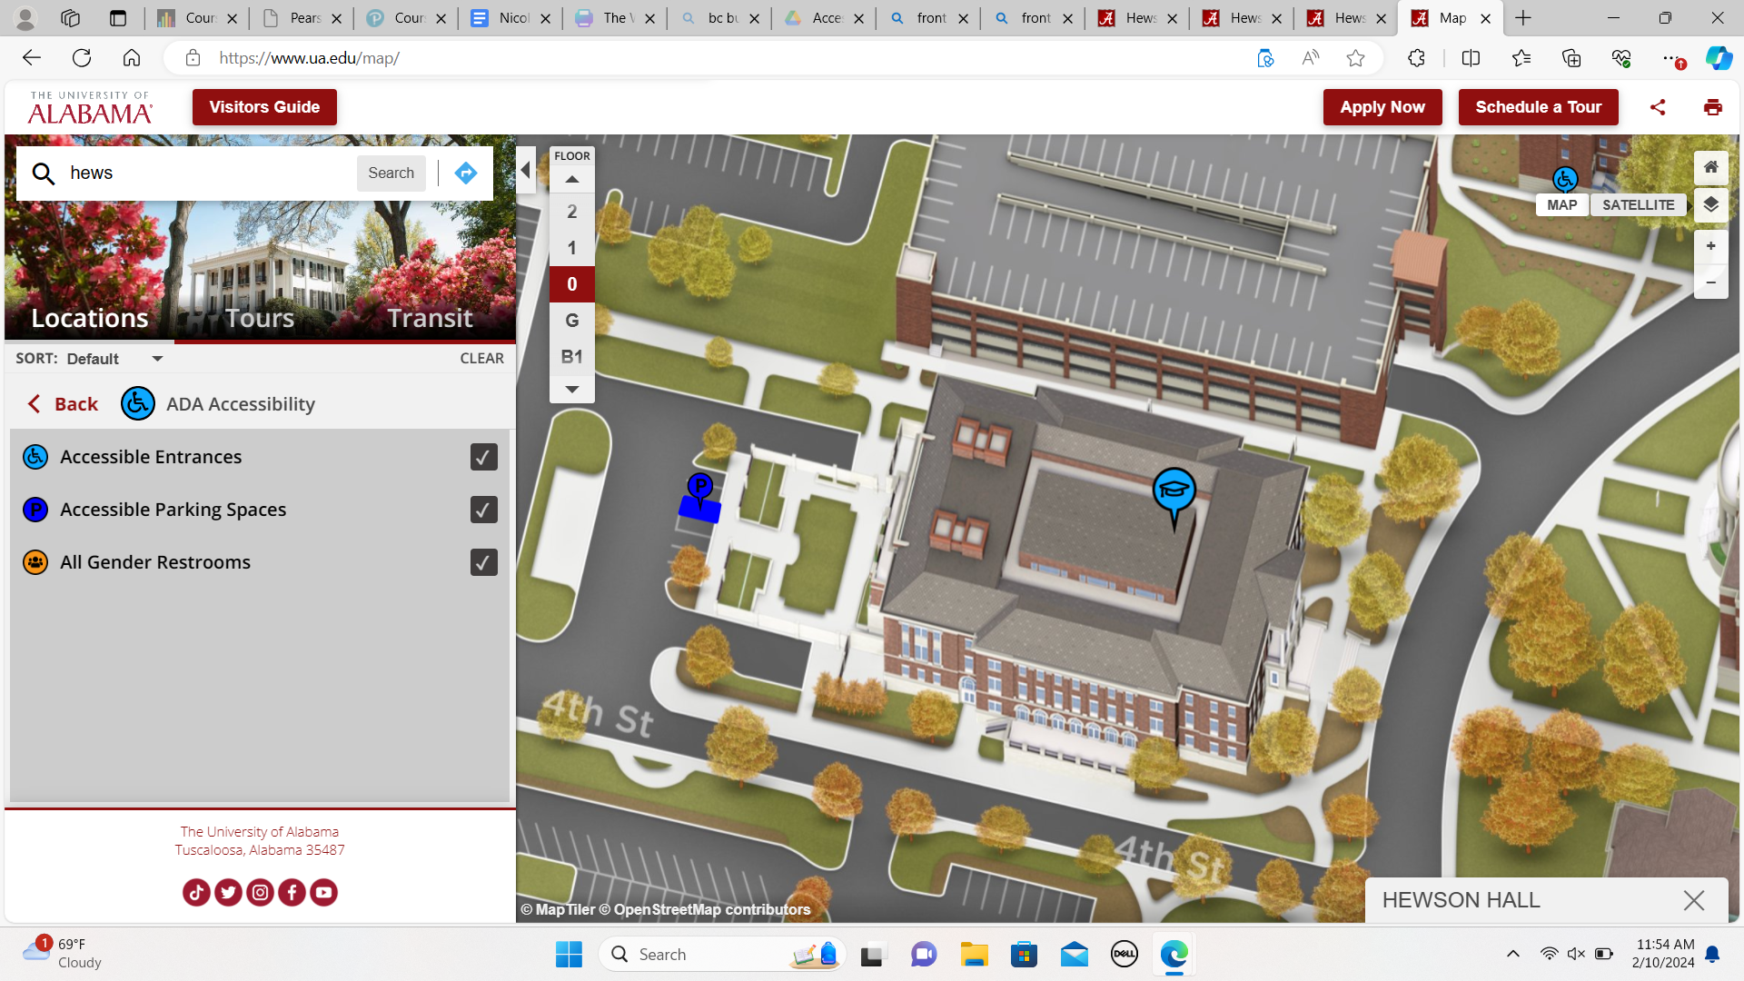

Image Descriptor: Aerial view of Hewson Hall. Drive up Stadium Drive. Make a left on 4th Street. Make a right at the first turn. The handicap parking spots are on the right-hand side. The map is available [online](https://ua.edu/map).

## Additional Modes of Transportation on Campus

### Veo Bike

If you're interested in exploring the campus on a Veo Bike, here's a guide on how to use them:

1. Download the Veo Mobile App:

Before you start your biking adventure, download the Veo Mobile App on your smartphone. You can find it on the App Store for iOS devices or Google Play for Android devices.

1. Create an Account:

Open the Veo Mobile App and create an account using your email address. Follow the on-screen instructions to set up your account, including payment details.

1. Locate Nearest Veo Bike:

Use the app to locate the nearest available Veo Bike. The app will display a map with the locations of nearby bikes.

1. Scan QR Code or Enter Bike ID:

Once you've found a bike, use the app to scan the QR code on the bike or manually enter the bike's ID to unlock it. The app will provide you with the necessary instructions.

1. Adjust the Bike:

Before you start riding, make sure the bike is adjusted to your liking. You can modify the seat height and handlebar position to ensure a comfortable ride.

1. Start Your Ride:

After unlocking the bike, you are ready to start your ride. Be sure to follow campus bike paths and road rules for safety.

1. Pause or End Your Ride:

If you need to make a pit stop, use the app to pause your ride. When you're ready to finish, park the bike in a designated area on campus, end the ride on the app, and lock the bike manually.

1. Payment:

Your account will be charged based on the duration of your ride. Check the app for the current pricing details.

1. Safety Tips:

Always wear a helmet for safety.

Follow traffic rules and be aware of pedestrians.

Park bikes in designated areas to avoid inconvenience.

1. Returning the Bike:

Make sure to return the bike to a designated Veo Bike parking area on campus. Lock the bike manually, and the app will confirm the end of your ride.

Follow these instructions to download the Veo Bike app:

For iOS Devices (iPhone/iPad):

1. Unlock your iOS device and open the App Store.
2. Tap on the "Search" tab at the bottom of the screen.
3. In the search bar, type "Veo Bike" and press Enter.
4. Look for the official Veo Bike app in the search results.
5. Once you find the Veo Bike app, tap on it.
6. On the app page, tap the "Download" button (it might display as a cloud icon if you have downloaded it before).
7. Wait for the app to download and install on your device.
8. Once installed, tap "Open" or locate the Veo Bike app on your home screen.

For Android Devices:

1. Unlock your Android device and open the Google Play Store.
2. Tap on the search bar at the top of the screen.
3. Type "Veo Bike" and press Enter.
4. Look for the official Veo Bike app in the search results.
5. Once you find the Veo Bike app, tap on it.
6. On the app page, tap the "Install" button.
7. Wait for the app to download and install on your device.
8. Once installed, tap "Open" or locate the Veo Bike app on your home screen.

Setting Up the Veo Bike App:

1. Open the Veo Bike app on your device.
2. Create a new account if you don't have one, or log in using your existing credentials.
3. Follow the on-screen prompts to set up your account and agree to any terms and conditions.
4. Once logged in, you can use the app to locate and unlock Veo Bikes around the University of Alabama campus.
5. Now you're ready to enjoy the convenience of Veo Bikes around UA’s campus.

If you encounter any issues or have questions, feel free to seek assistance from the Veo Bike support within the app.

### Bus Service

Welcome to the University of Alabama! Navigating the campus efficiently is key to your success. Here's a guide to using on-campus transportation options:

1. Crimson Ride Shuttle Service:

* The Crimson Ride Shuttle Service is a mode of transportation on campus. It's a free shuttle service available to all students, faculty, and visitors.
* Look for designated Crimson Ride shuttle stops across campus. These stops are marked with signs indicating the shuttle routes.
* Buses only run Monday through Friday from 7:00 am - 7:00 pm
* Download the "Passio GO!" app on your smartphone. This app provides real-time tracking of Crimson Ride shuttles, allowing you to see when the next shuttle will arrive at your stop.
  + Routes via Passio GO! are also available alongside frequently asked question on Crimson Ride’s website
    - [Crimson Ride](https://crimsonride.ua.edu/)
* Wheelchair Accessibility on Crimson Ride Buses
  + Crimson Ride buses lower on hydraulics level with the sidewalk, allowing easy access to the bus
  + Each bus is also equipped with a ramp, allowing a wheelchair passenger to board
  + Each Bus has designated wheelchair spaces
* Please Contact the Office of Disability Services for any more information on ADA-compliant shuttles and other transportation accommodations.
  + [Contact Us](https://ods.ua.edu/contact-us/)

**Important Note:**

* Bus Routes can be delayed and have the opportunity to change throughout the day. If you do not have a smartphone or access to the internet while attempting to ride a bus, this mode of transportation is not recommended.

# Pediatric Care Medical Conference Itinerary

Saturday, February 17th

### **8:00 am - 8:45 am:** Room 002: General Welcome Session

Join us for a warm welcome from the conference directors and hosts, Dr. Eli Williams and Dr. Penny Dey. Get acquainted with the agenda for the day and learn about the exciting topics that will be covered throughout the conference.

### **9:00 am - 9:45 am:** Concurrent Session 1 (Choose One)

**Room 1003:** Discussion Panel with St. Jude's Top Pediatric Surgeons  
Engage in a thought-provoking discussion led by top pediatric surgeons from St. Jude, exploring innovative approaches and best practices in pediatric surgery.

**Room 1007**: Demonstration of New Surgical Technique by Dr. Daina Lynn  
Witness a live demonstration by Dr. Daina Lynn as she showcases a cutting-edge surgical technique that promises to revolutionize pediatric surgery on a manikin.

**Room 1023:** Presentation of New Bacterial Disease by Dr. Kim Lake  
Gain insights into the latest developments in pediatric infectious diseases as Dr. Kim Lake presents on a new bacterial disease affecting children.

**Room 1028**: General Discussion Room led by Dr. Dredan Birn  
Join Dr. Dredan Birn for an interactive discussion on a variety of pediatric care topics, where participants can share their experiences and insights.

### **10:00 am - 10:45 am:** Concurrent Session 2 (Choose One)

**Room 1003:** Discussion Panel with St. Jude's Top Pediatric Surgeons

**Room 1007:** Demonstration of New Surgical Technique by Dr. Daina Lynn

**Room 1023:** Presentation of New Bacterial Disease by Dr. Kim Lake

**Room 1028:** General Discussion Room led by Dr. Dredan Birn

### **11:00 am - 11:45 am:** Room 002: Presentation by Dr. Fillip Dress Dr. Fillip Dress will delve into the latest research findings in pediatric care, providing valuable insights into new advancements and breakthroughs in the field.

### **12:00 pm - 1:00 pm:** James Quiet Study: Lunch Break Enjoy a delicious lunch and network with fellow attendees.

### **1:00 pm - 1:45 pm:** Aviary: Tabeling Event

Discover a wide range of medical equipment, prescription medications, laboratory supplies, and more offered by various vendors at the tabling event.

### **2:00 pm - 2:45 pm:** Concurrent Session 3 (Choose One)

**Room 1003:** Discussion Panel with St. Jude's Top Pediatric Surgeons

**Room 1007:** Demonstration of New Surgical Technique by Dr. Daina Lynn

**Room 1023:** Presentation of New Bacterial Disease by Dr. Kim Lake

**Room 1028:** General Discussion Room led by Dr. Dredan Birn

### **3:00 pm - 3:45 pm:** Concurrent Session 4 (Choose One)

**Room 1003:** Discussion Panel with St. Jude's Top Pediatric Surgeons

**Room 1007:** Demonstration of New Surgical Technique by Dr. Daina Lynn

**Room 1023:** Presentation of New Bacterial Disease by Dr. Kim Lake

**Room 1028:** General Discussion Room led by Dr. Dredan Birn

### **4:00 pm - 4:45 pm:** Room 002: Presentation by Dr. Gram Archer

Dr. Gram Archer will lead a session on patient ethics, providing guidance and best practices for navigating ethical dilemmas in patient care, particularly in interactions with patients and their parents.

### **5:00 pm:** Optional: Campus Tour

Explore the beautiful campus of the University of Alabama and discover its rich history and vibrant community with our Capstone Men and Women.

# Building Layout

## General Information

### Hewson Hall

Address: 380 Stadium Drive, Tuscaloosa, Alabama 35487

Interactive Websites:

* [Hewson Hall – The Culverhouse College of Business | The University of Alabama (ua.edu)](https://culverhouse.ua.edu/hewson/)
* [Map - University of Alabama (ua.edu)](https://www.ua.edu/map/)

## Entrances

### Front Entrance

#### Wheelchair Accessible

1. When looking at the front of Hewson Hall, there is an accessible ramp to the left-hand side.
2. Upon approaching the door, there is a button to push in order to trigger the automatic door.
3. There is also an automatic door button next to the second set of doors.

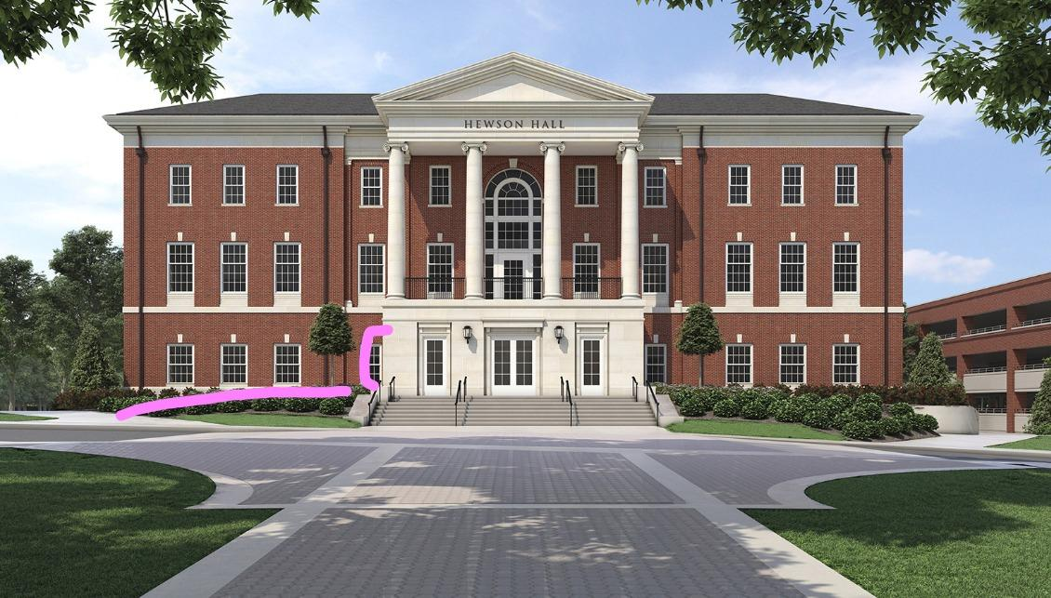

Image Descriptor: Ground-view image of the front of Hewson Hall. Highlighted in pink is where the accessible ramp pathway is found.

#### Automatic Doors

1. When looking at the front of Hewson Hall, there are automatic doors on the left and right side of the three-sided entrance (including the wheelchair accessible ramp)
2. Upon clicking the button, it will trigger the opening on the door
3. There is also an automatic door button next to the second set of doors

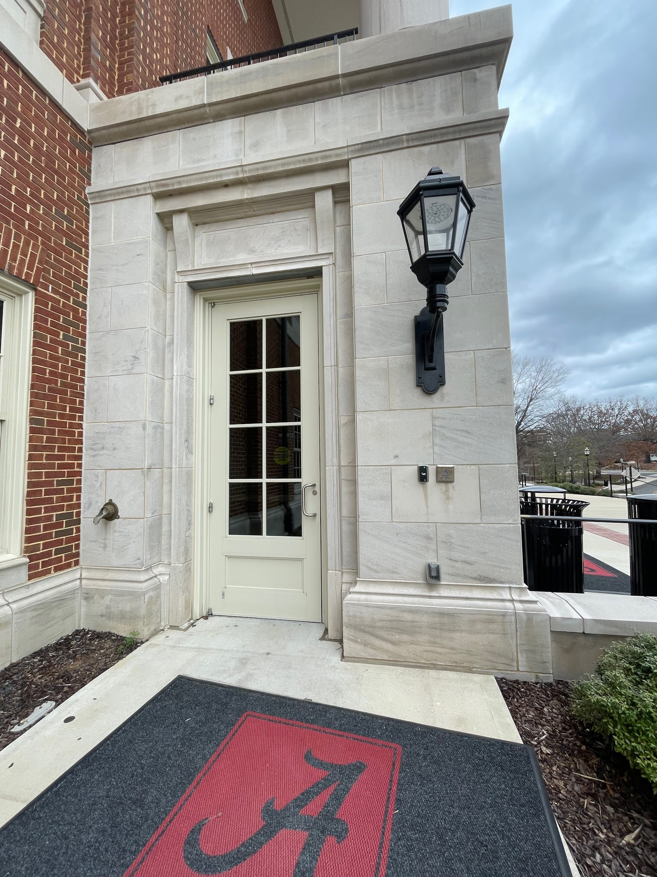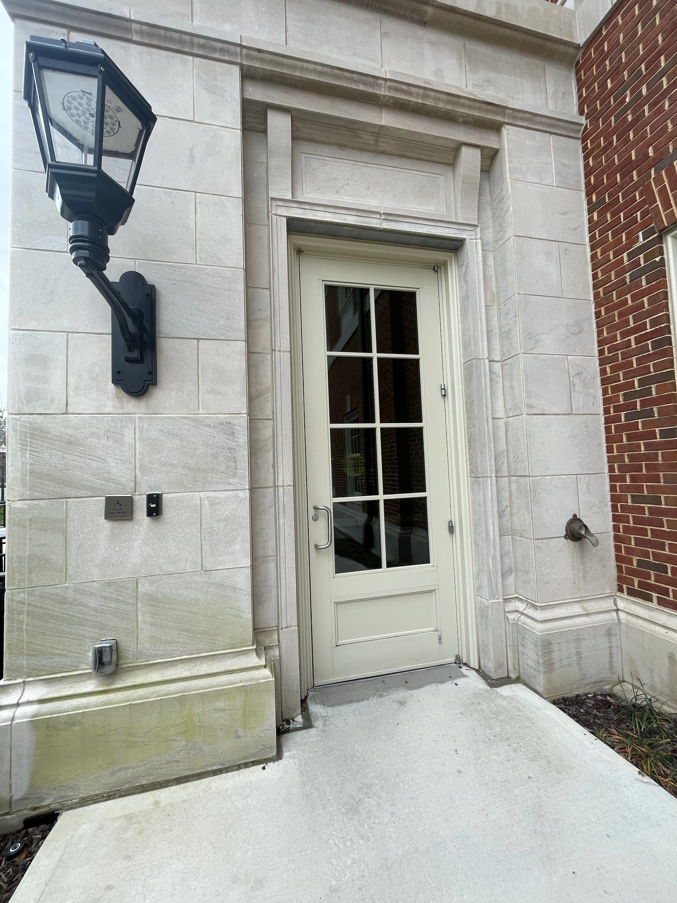

Image Descriptors: (First Image) Ground-view picture of the exterior automatic door entrance from the left-hand side. Shows where the automatic door button is placed on the building.

(Second Image) Ground-view picture of the exterior automatic door entrance from the right-hand side. Shows where the automatic door button is placed on the building.

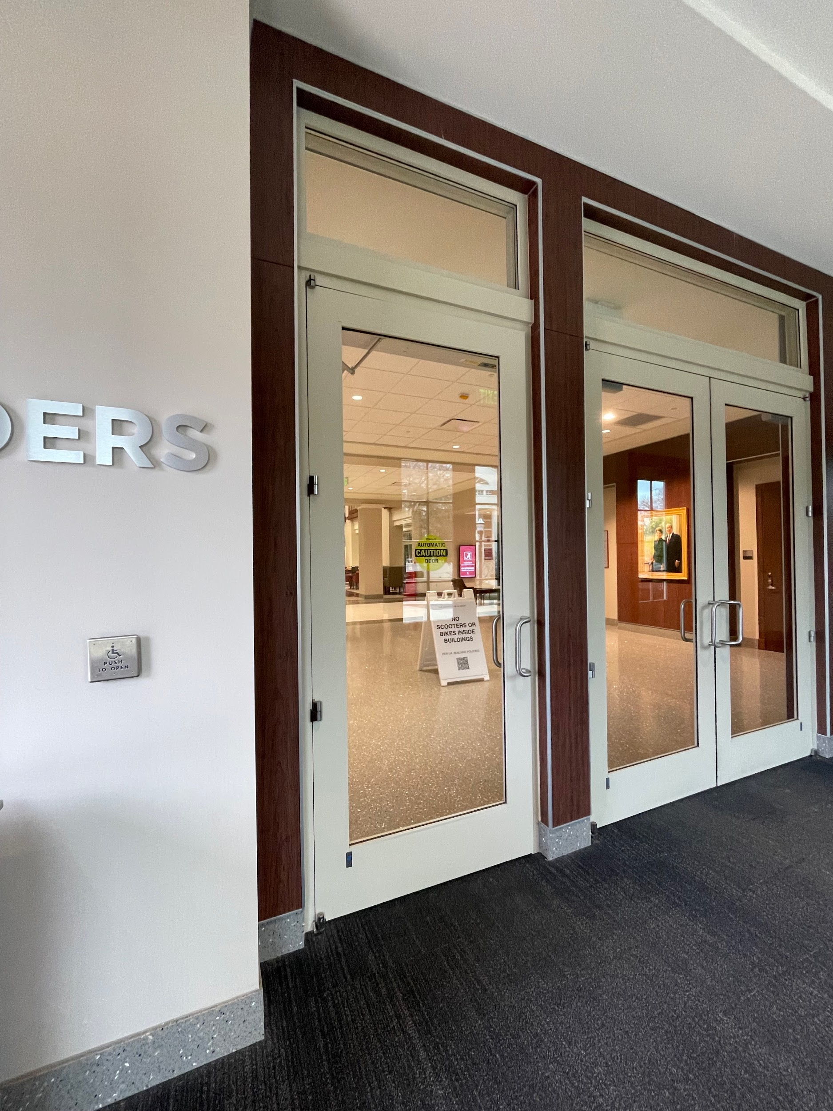

Image Descriptor: Ground-view picture of the interior automatic door that leads into the atrium. Shows where the automatic door button is placed on the building’s wall.

### Side Entrances

#### Wheelchair Accessible

The entrances at the sides of the building are not wheelchair accessible.

There are either stairs leading up to the doors or there are stairs upon entering the doors.

#### Automatic Doors

There are no automatic door buttons that trigger the opening of the door.

### Back Entrance

#### Wheelchair Accessible

There is a ramp leading down to the back entrance of the building.

There are two doors that are accessible entrances.

Please reference the image below.

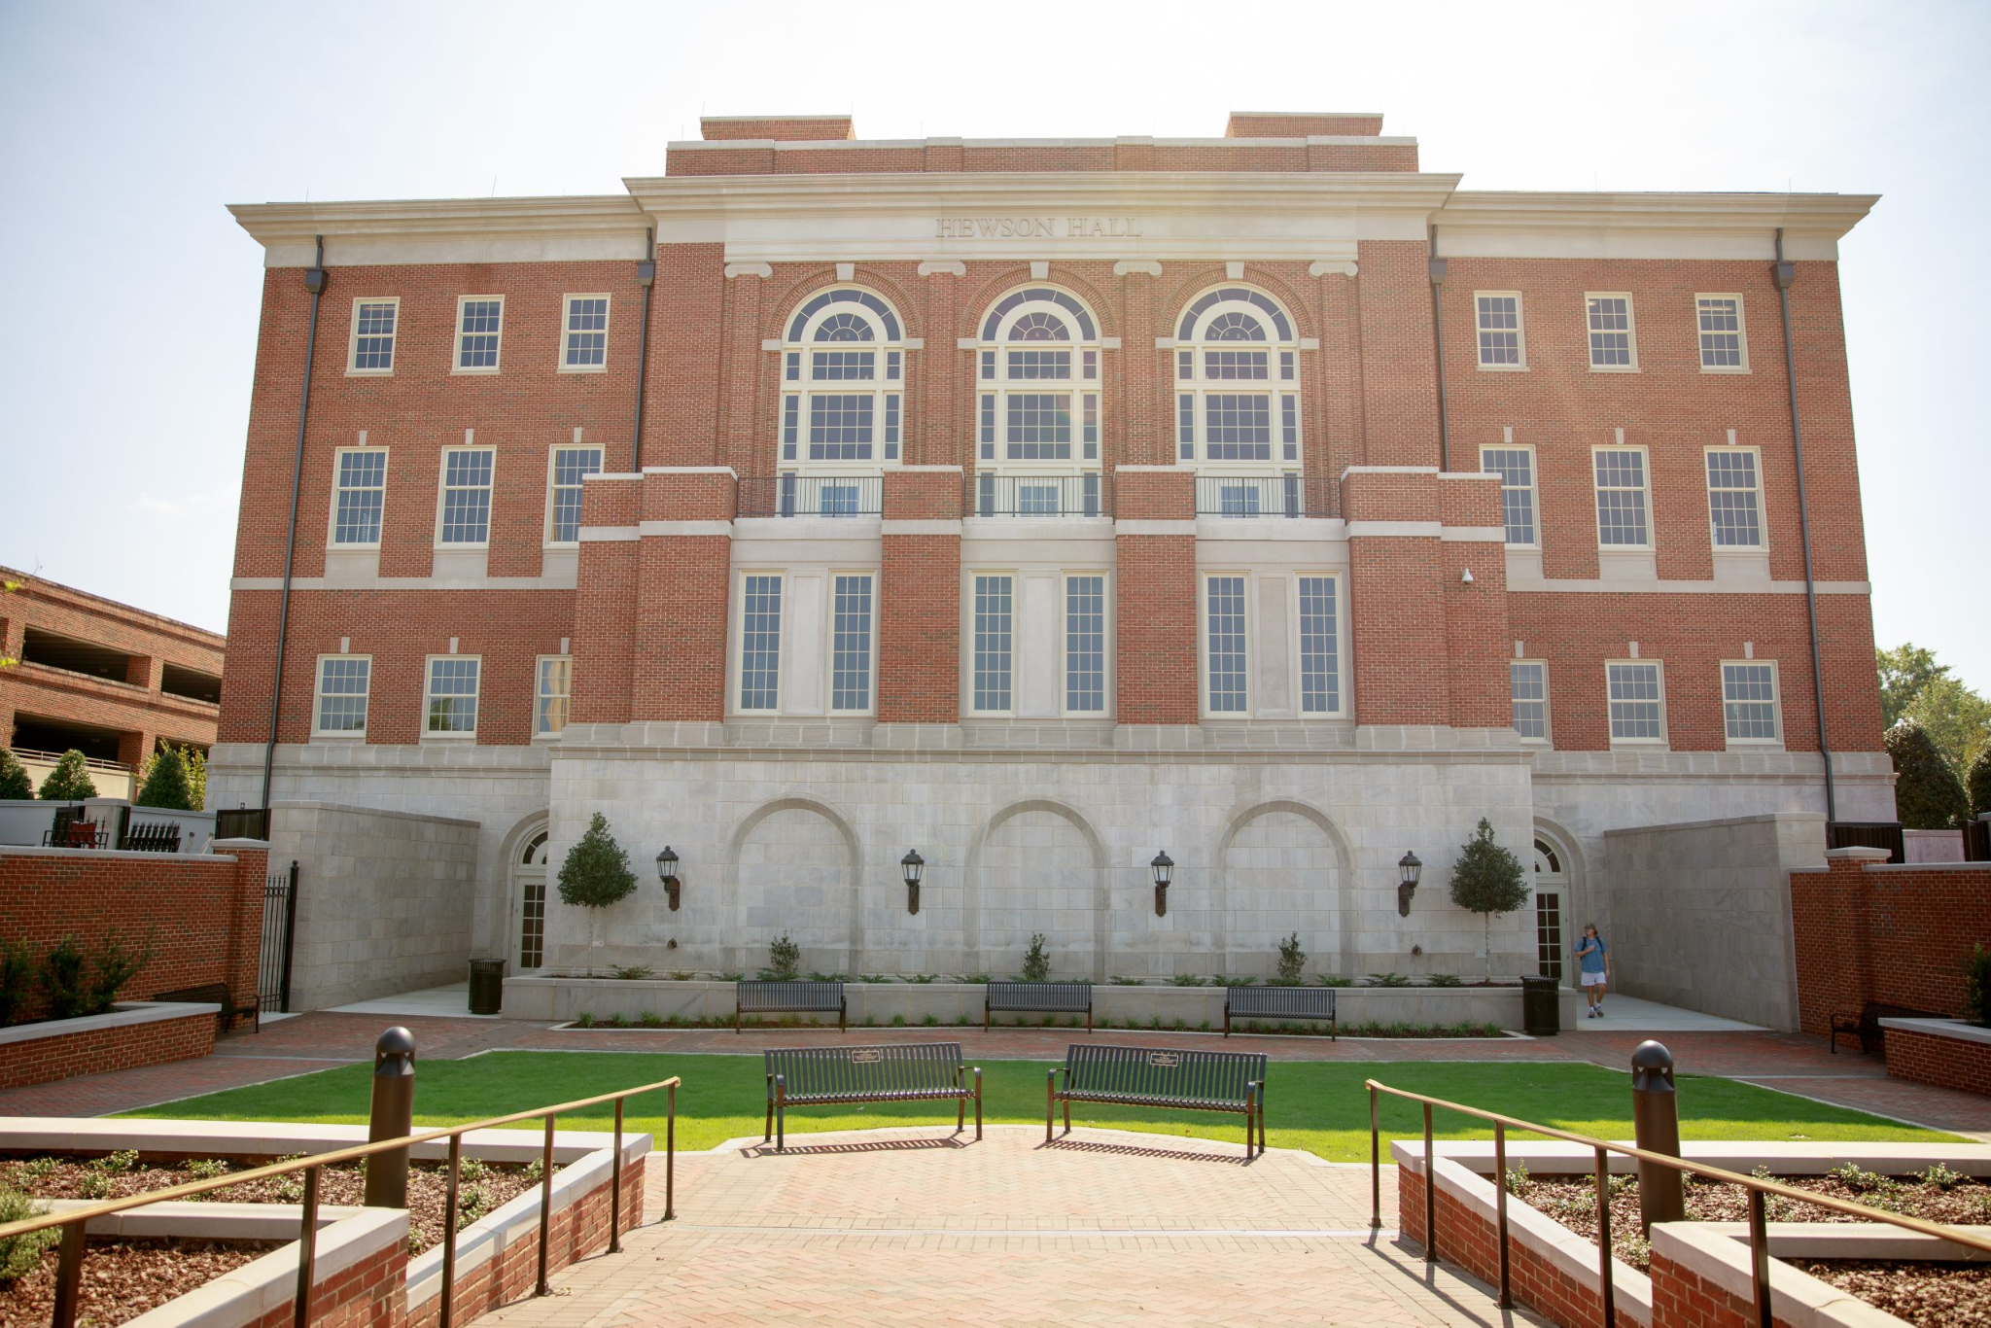

Image Descriptor: Ground view of the back of Hewson Hall. Shows the ramp and two back entrances.

#### Automatic Doors

There are buttons that trigger the automatic door to open, as well as the second set of doors (which open towards the outside).

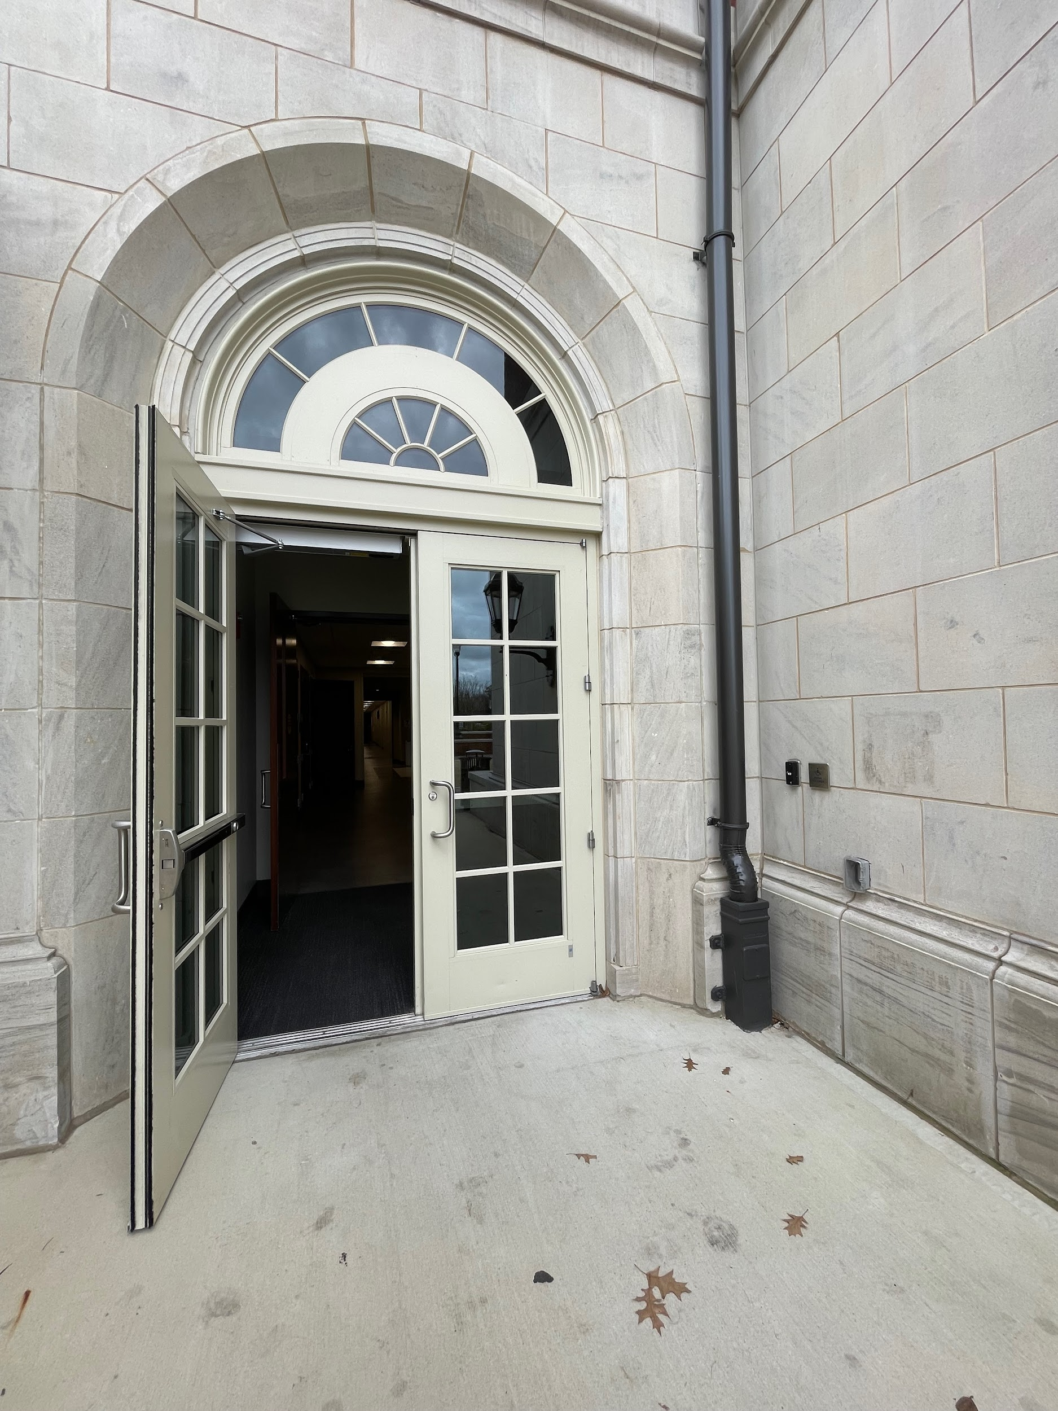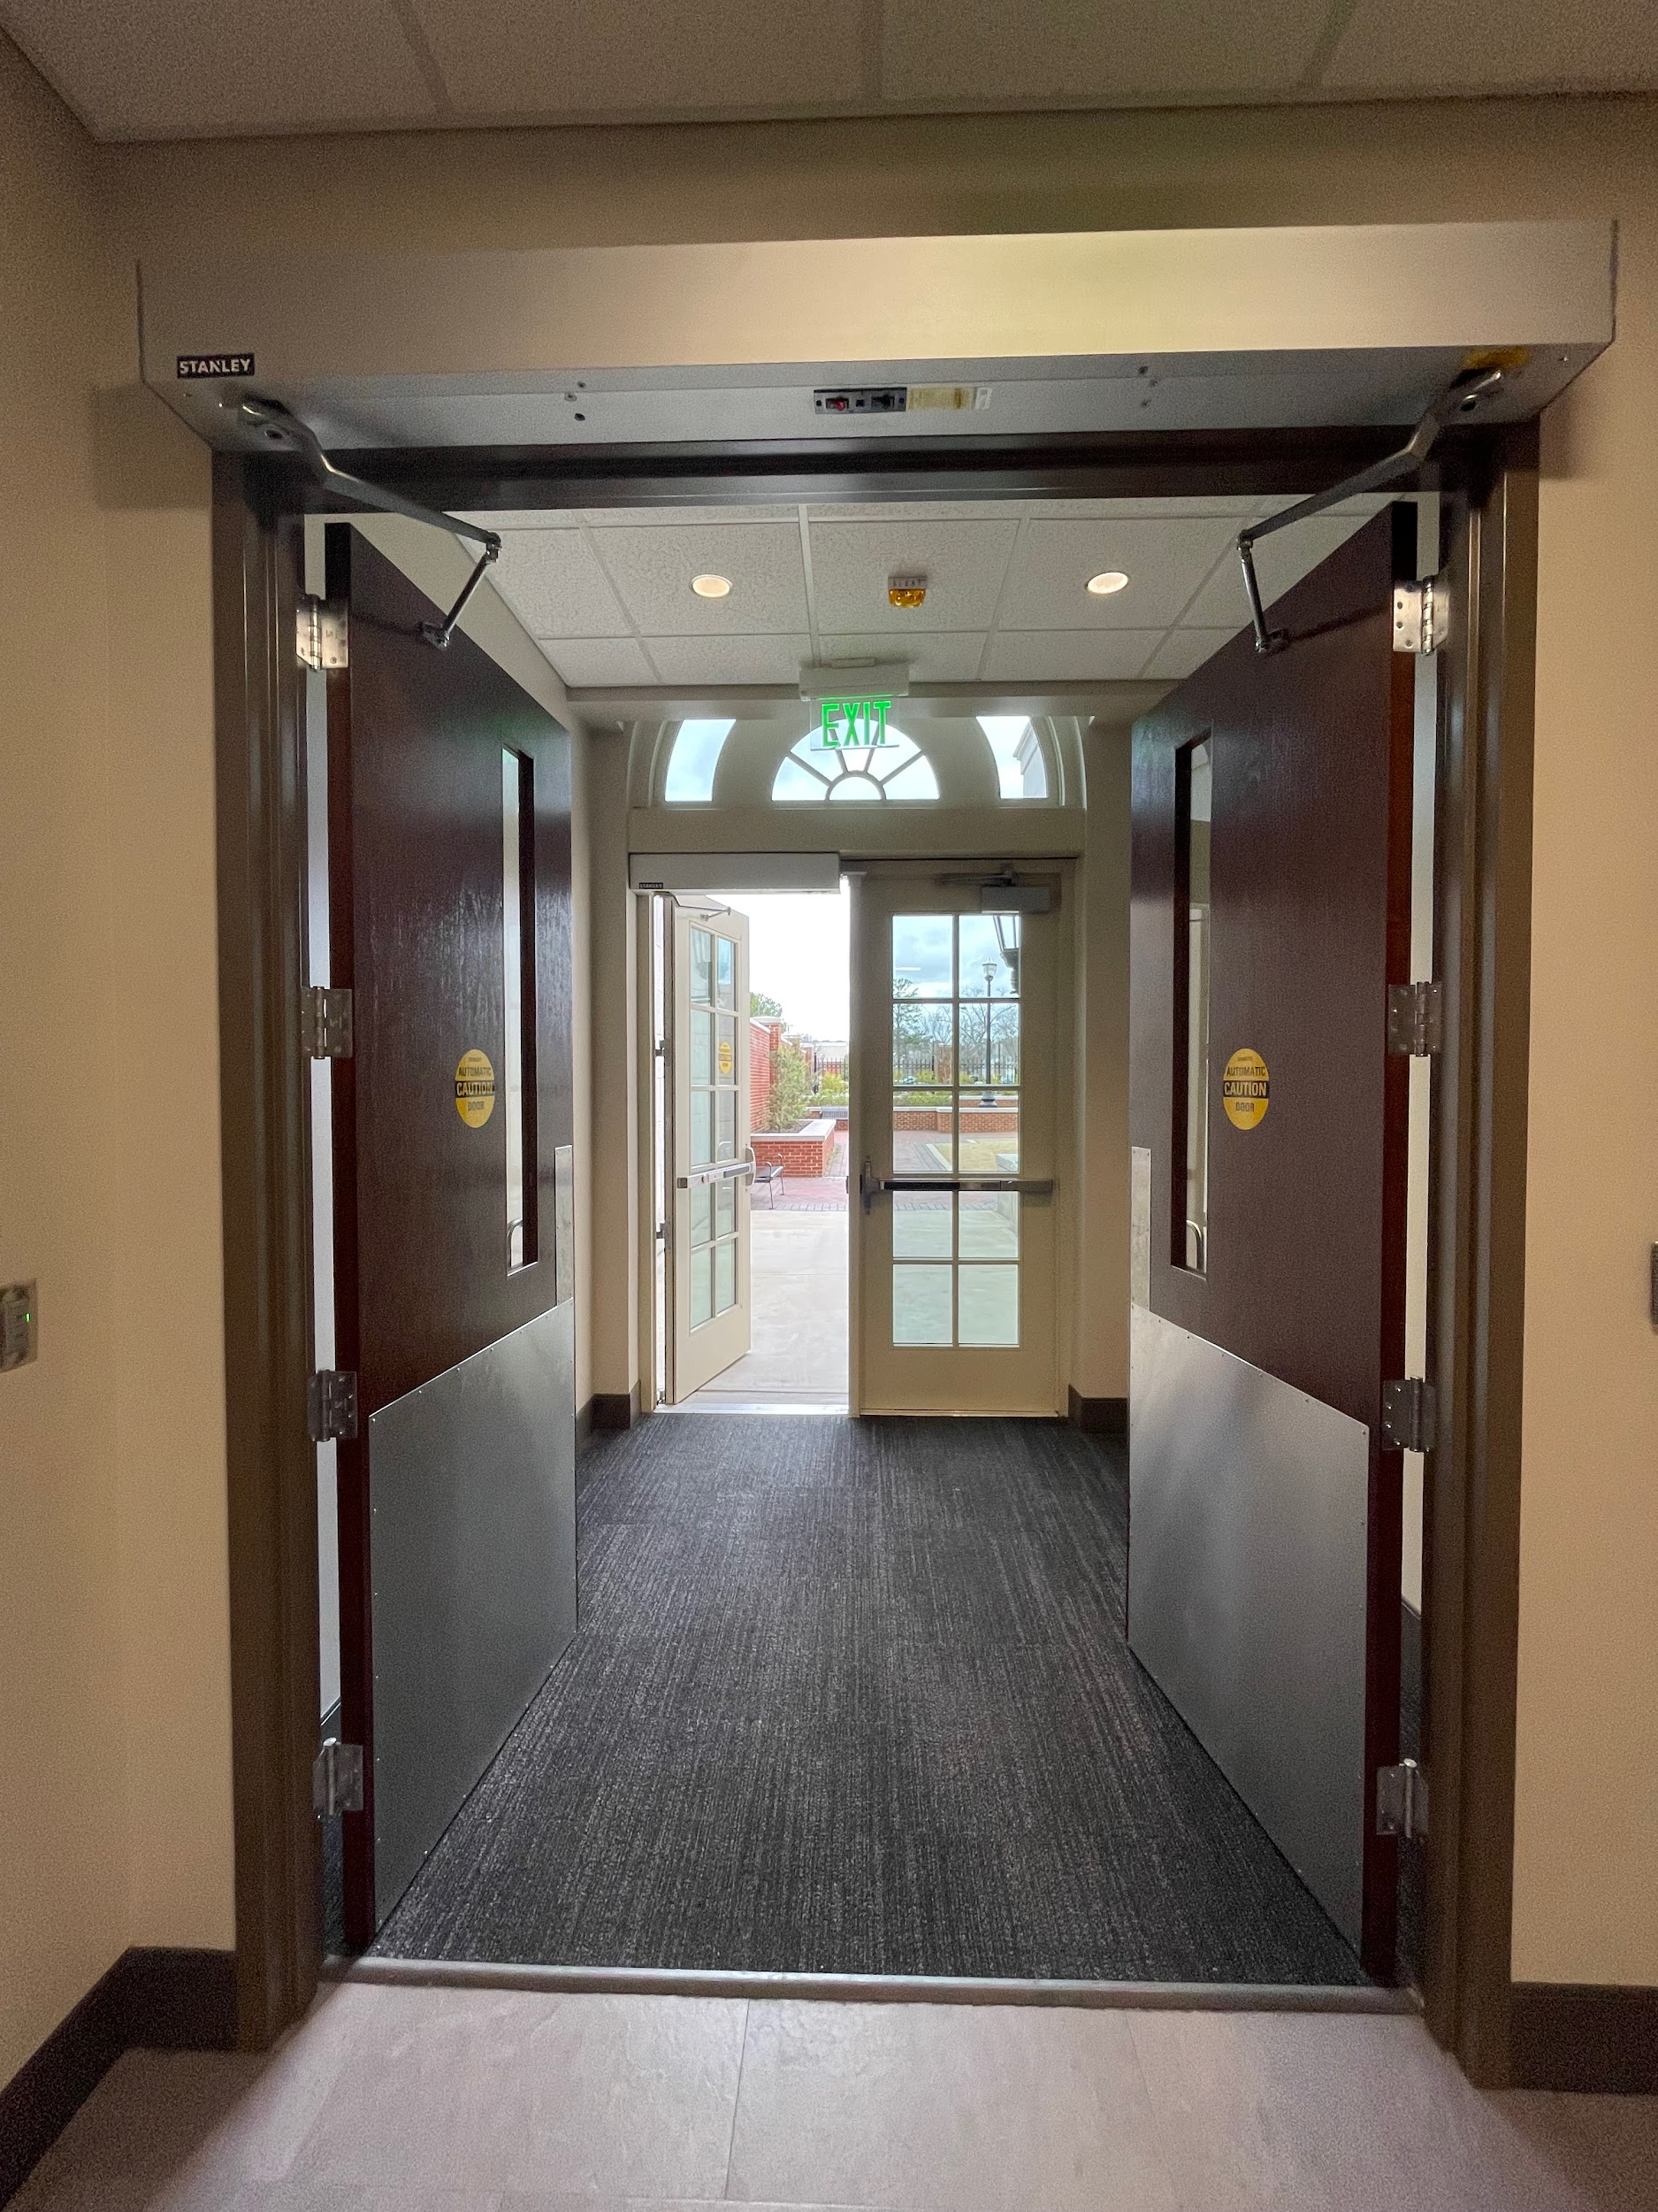

Image Descriptors: (First Image) Ground-view picture of the exterior back entrances. Shows where the automatic door button is on the wall.

(Second Image) Ground-view picture of the interior back entrances.

## Hallways

All hallways are accessible, as per up-to-date 2021 building code, to make all new buildings accessible.

## Elevators

The elevators are accessible, as per up-to-date 2021 building code, to make all new buildings accessible.

The Hewson Hall elevators are located in the same spot on every floor. They are located at the back of the building, towards 4th Street W.

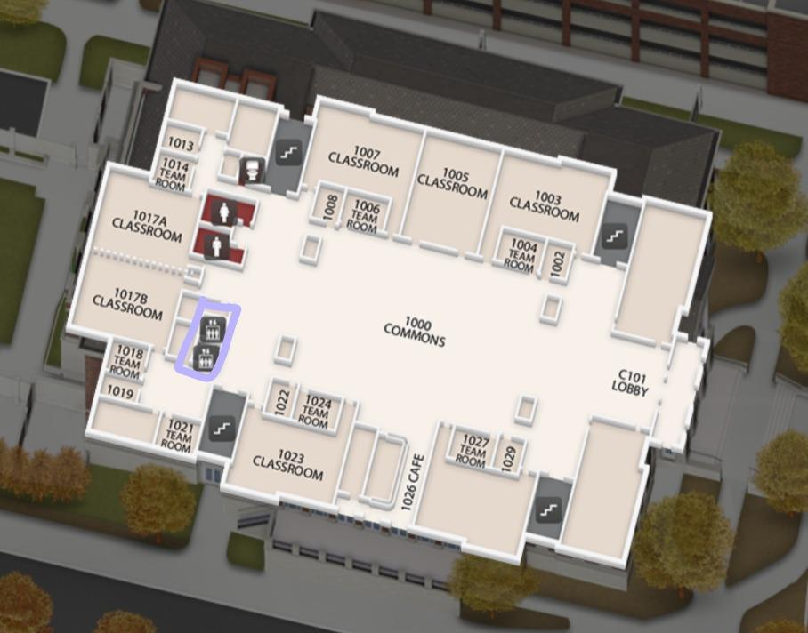

Image Descriptor: Aerial view of Hewson Hall’s 1st floor. Shows the floor plan, which includes the numbered classrooms, numbered team rooms, bathrooms, stairs, cafe, and elevators. The elevators are indicated by a purple box.

## Wheelchair Accessible Seating

In every room and area, there is wheelchair accessible seating.

### Room 0002

There are wheelchair accessible seating in the front, middle, and back of the room. There are three at the front of the room. One in the middle. Two in the last row. Attached is a visual aid to locate those seats.

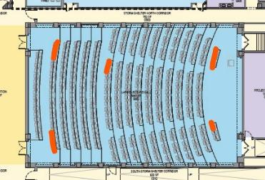

Image Descriptor: Aerial-view of Room 002. Highlighted in burnt-orange are areas where there is wheelchair specific seating.

### Room 1003

The wheelchair accessible seating is located at the front of the room. These sections are marked by the wheelchair stickers. If more seating is needed, extra accommodations can be made. Please contact Kenneth Jerald (Phone #: (205) 555-5432).

### Room 1007

The wheelchair accessible seating is located at the front of the room. These sections are marked by the wheelchair stickers. If more seating is needed, extra accommodations can be made. Please contact Kenneth Jerald (Phone #: (205) 555-5432).

### Room 1023

The wheelchair accessible seating is located at the front of the room. These sections are marked by the wheelchair stickers. If more seating is needed, extra accommodations can be made. Please contact Kenneth Jerald (Phone #: (205) 555-5432).

### Room 1028

The wheelchair accessible seating is located at the front of the room. These sections are marked by the wheelchair stickers. If more seating is needed, extra accommodations can be made. Please contact Kenneth Jerald (Phone #: (205) 555-5432).

## Ramps

### External

The sides of the building do not have stairs or a ledge at any point.

### Internal

The only ramp in the building is at ground level.

**Warning.** This is a potentially steep ramp, but the room is accessible without having to go down the ramp.

## Restrooms

Men’s and women’s restrooms are located to the right of the elevators on each floor. Each restroom contains a changing station and an accessible stall. The restrooms do not have automatic doors.

To the right of the primary restrooms and left of the stairs is a non-gendered family restroom. Note that it does not contain a changing table.

# 

Image Descriptors: (First Image) Ground-view of the Hewson Hall restrooms. Shows the layout of the women’s bathroom, where the accessible stall is all the way at the end to the left.

(Second Image) Ground-view of the changing tables in the men’s and women’s restrooms.

# Auto and Visual Accessibility

## Within Conference Rooms

In each room, the person speaking will be equipped with a microphone. This microphone can be heard throughout the room by speakers.

Another system auto-generates closed captions, which are connected through the microphone.

## Throughout Building

Each classroom has a plaque that explicitly labels the name and number of it, and this is uniform throughout the building. Braille is also on each plaque as an aid.

Attached is a visual of the plaques.

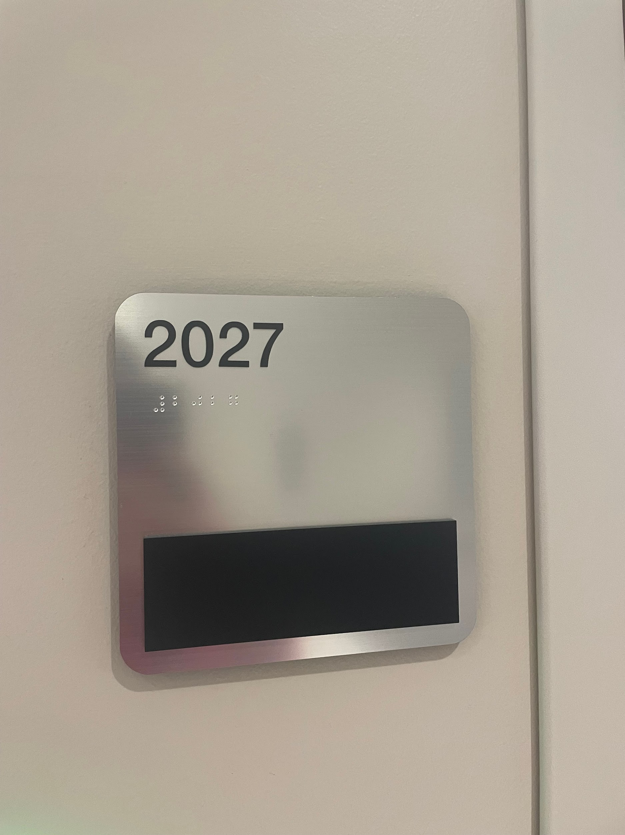

Image Descriptor: Shown is the uniform signage that is outside every room and is used for any directions. It is stainless steel with the room number on the top left in black. Under the room number is the accompanied braille translation.

# Additional Conference Information

## Quiet Room

There is a quiet room provided on the 1st and 2nd floor.

### 1st Floor

On the 1st floor, the quiet room is Team Room 1018.

Attached is a visual aid of its location.

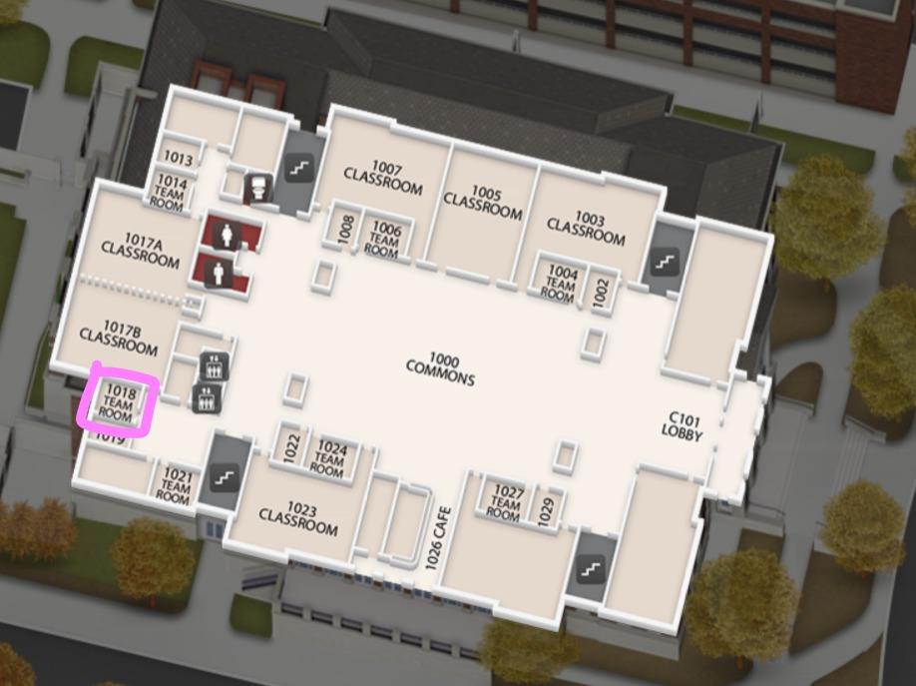

### 2nd Floor

On the 2nd floor, the quiet room is Conference Room 2013.

Attached is a visual aid of its location.

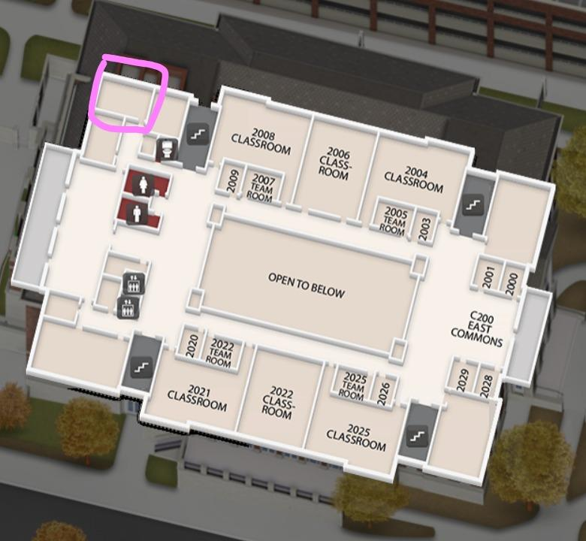

Image Descriptor: Aerial-view of the 2nd floor of Hewson Hall. Highlighted in pink is the conference room blocked off.

## Family Accessibility

### Childcare

In order to allow working mothers and/or fathers to join us, there is a room dedicated to childcare for children 1-12 years of age. The room is Classroom 2006.

Attached is a visual aid of its location.

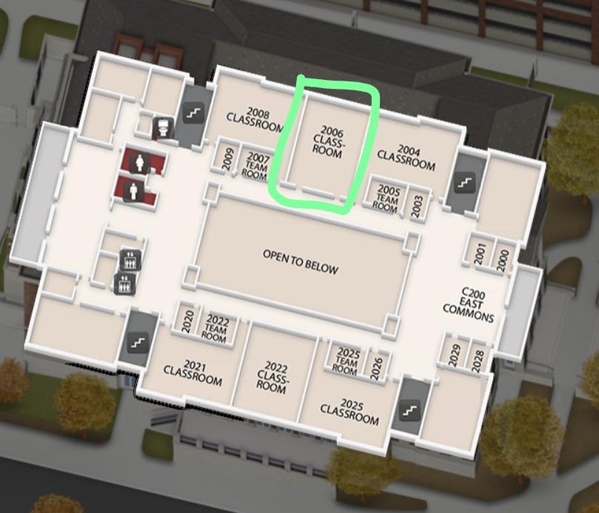

Image Descriptor: Aerial-view of the 2nd floor of Hewson Hall. Highlighted in green is the classroom room blocked off.

### Nursing Room

On the 1st floor, there is a room dedicated to allow mothers to nurse their child in privacy.

The dedicated nursing room is Team Room #1014.

Attached is a visual aid where the room is located.

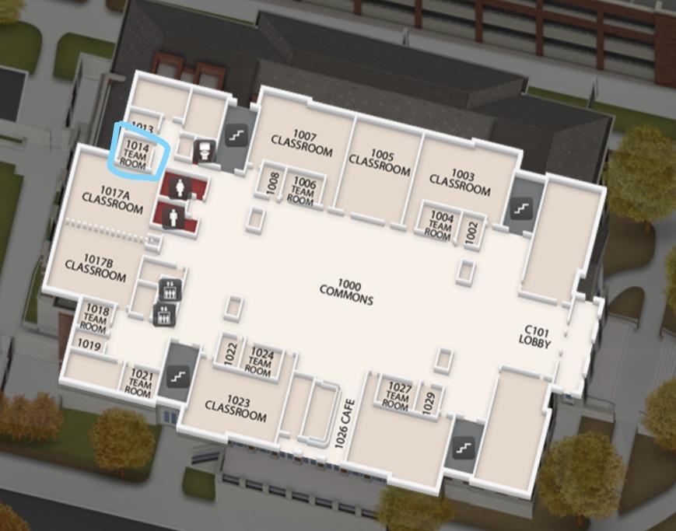

Image Descriptor: Aerial-view of the 1st floor of Hewson Hall. Highlighted in blue is the team room that is blocked off.

## Additional Person(s)

If you require an additional person to attend with you to this event please contact the ADA coordinator Kenneth Jerald: (205) 555-5432 [kjhealth@pediatrics.com](mailto:kjhealth@pediatrics.com).

## Smoking Areas

“UA has not allowed smoking inside University buildings since 1991. In 2007, the policy was expanded to ban smoking within 30 feet of University buildings with the exception of one exit. Effective Jan. 1, 2015, The University of Alabama will extend its smoke-free policy to include all facilities, grounds and parking areas on the UA campus.”

For more information please see the University of Alabama’s website. [Smokefree | The University of Alabama (ua.edu)](https://www.ua.edu/campuslife/smokefree#:~:text=UA%20has%20not%20allowed%20smoking%20inside%20University%20buildings,grounds%20and%20parking%20areas%20on%20the%20UA%20campus.)

# Accessible Food Options

## Within the Building

**Cooper Cafe** is located on the first floor, on the left-hand side of the building.

It has multiple beverage options, including coffee and teas.

It also has a variety of food options, including already prepared sandwiches, fruit, etc.

## Near the Building

**Publix:** Grocery store that also has a deli inside.

**Mediterranean Co.:** Southern and Mediterranean cuisine, which highlights their gyros, paninis, soups, salads, and pasta.

**Buffalo Phil’s:** Pub and cafe styled food, which highlights their buffalo wings, sandwiches, and salads.

**The Standard:** Local pizzeria, which highlights their pizza and wings.

**Chipotle:** Mexican grill chain, which highlights their burritos, bowls, and other Mexican-styled cuisine.

## Provided Meals

Only lunch will be provided during the conference at 12:00 pm. The RSVP form will include dietary restrictions. For further questions or changes to RSVP form regarding dietary restrictions, please contact ADA Coordinator Kenneth Jerald (205) 555-5432 [kjhealth@pediatrics.com](mailto:kjhealth@pediatrics.com).

# Emergency Response

## Tornado Information

# Being in Tuscaloosa, Alabama, tornadoes are a real and potentially life-threatening concern. Being informed and prepared for these severe weather events is crucial. Tornadoes can strike with little warning, causing significant damage and posing serious risks to safety. Understanding the importance of tornado preparedness and knowing how to respond during tornado watches and warnings are essential.

The University of Alabama provides valuable resources, including severe weather guidelines (<https://ready.ua.edu/severe-weather-guidelines/>) and information on available shelters (<https://ready.ua.edu/shelters/>), to help ensure your safety during these emergencies. By familiarizing yourself with these resources and taking proactive steps to prepare, you can better protect yourself and others in the event of a tornado. Stay informed, stay safe.

### Tornado Watch:

A tornado watch is issued by the National Weather Service when weather conditions are conducive to the formation of tornadoes in and around the specified area. During a tornado watch, it is essential to stay vigilant and be prepared to take action if necessary.

During a tornado watch, individuals should stay informed by monitoring local weather reports and alerts. Review your emergency plan and ensure that you know the location of the nearest tornado shelter. Be prepared to take shelter quickly if a tornado warning is issued.

### Tornado Warning:

A tornado warning is issued by the National Weather Service when a tornado has been spotted on radar or observed by trained spotters. A tornado warning indicates imminent danger and requires immediate action to protect life and property.

If a tornado warning is issued, take immediate action to seek shelter in a safe location. Proceed to the designated tornado shelter in Hewson Hall, located on the bottom floor. Move quickly and calmly to the shelter, avoiding windows and exterior walls. Stay inside the shelter until the warning has expired and it is safe to emerge.

### How to Respond:

* **Stay Informed:** Monitor local weather reports and alerts for updates on tornado watches and warnings.
* **Review Emergency Plan:** Familiarize yourself with the location of the nearest tornado shelter and review your emergency plan with colleagues and fellow conference attendees.
* **Take Shelter:** If a tornado watch is issued, stay alert and prepared to take shelter if necessary. In the event of a tornado warning, seek shelter immediately in the designated tornado shelter in Hewson Hall.
* **Stay Safe:** Remain inside the shelter until the tornado warning has expired and it is deemed safe to exit. Follow any additional instructions from conference staff or emergency personnel.k

By understanding the difference between a tornado watch and a tornado warning and knowing how to respond appropriately to each, conference attendees can help ensure their safety and well-being in the event of severe weather.

## Fire Safety

The University of Alabama prioritizes fire safety across its campus. Equipped with advanced fire alarm systems, the campus utilizes loud sirens strategically placed within buildings to promptly alert occupants during fire emergencies. These sirens may emit high-decibel sounds, which may be a sensory concern for some individuals. Additionally, our emergency notification system utilizes speakers and digital signage to provide clear instructions for evacuation and safe exit routes. Comprehensive response protocols emphasize immediate evacuation, avoidance of elevators, and prompt reporting of fires. The speakers will give instructions on what type of emergency is present and how to properly respond to the situation. There is signage throughout the building on the appropriate evacuation route.

## UA Safety App

The UA Safety app is a mobile application provided by the University of Alabama, designed to enhance campus safety and security. It offers features such as emergency alerts, safety resources, campus maps, and reporting tools to help keep students, faculty, and staff informed and prepared in case of emergencies.

To Download the app:

1. **Open App Store or Google Play Store**: Launch the App Store on your iOS device or the Google Play Store on your Android device.
2. **Search for "UA Safety"**: In the search bar, type "UA Safety" and press enter.
3. **Locate the App**: Look for the UA Safety app in the search results. It should be the official app provided by the University of Alabama.
4. **Download the App**: Tap on the UA Safety app icon to open its details page. Then, tap on the "Download" or "Install" button to begin downloading the app to your device.
5. **Wait for Installation:** Wait for the app to finish downloading and installing on your device. This may take a few moments depending on your internet connection speed.
6. **Open the App**: Once the installation is complete, tap on the "Open" button to launch the UA Safety app.
7. **Set Up Your Account:** Follow the on-screen instructions to set up your account within the app. This may involve providing some basic information and agreeing to the app's terms of use.
8. **Grant Permissions:** Upon launching the app for the first time, you may be prompted to grant certain permissions, such as access to your location or notifications. Be sure to allow these permissions to ensure the app functions properly.
9. **Enable Notifications (Optional):** To receive timely alerts and updates from the UA Safety app, consider enabling notifications in your device's settings.

For more information visit [UA Safety Mobile App – The Center for Advanced Public Safety | The University of Alabama](https://www.caps.ua.edu/software/ua-safety-mobile-app/)

# Additional Accessibility Information

If there are any accommodations not addressed in this document or any questions, please contact ADA Coordinator Kenneth Jerald: (205) 555-5432 [kjhealth@pediatrics.com](mailto:kjhealth@pediatrics.com).

If there are any issues upon arrival to Birmingham / Tuscaloosa, please contact Event coordinator Erika Johnson: (205) 555-6543 [ejhealth@pediatrics.com](mailto:ejhealth@pediatrics.com).

For this assignment's preparation, the author(s) have utilized ChatGPT, a language model created by Open AI. Within this assignment, ChatGPT was used for purposes such as forming teh itinerary, editing the introduction, formulating the tornado information, and editing of grammar for the entire document.